|  |
| --- |
| University of Sunderland |
| Centralised vs Decentralised version control |
| An overview of the three version control systems, and their overall differences. |

|  |
| --- |
| Heslop, Alan John  10-17-2020 |

# What is a version control system?

Version control system (VCS) is a set of tools that aids in the management and records changes to source code over time. Version control can help users to revert to a previous version if a mistake/bug is made known, the team will implement this to rollout quickly to minimize disruption and/or overall downtime to the “live” version. Overall, this system can be used to see who modified which version and when, allowing for a quick resolution to prevent the issue happening again.

# There are three types of version control;

# Local Version Control:

Local version control was and still is an older custom in which a user creates a python file for example and wants to test some new code. The user will then copy the .py file into the same directory, or different directory, and then rename it ending .old (or something similar).

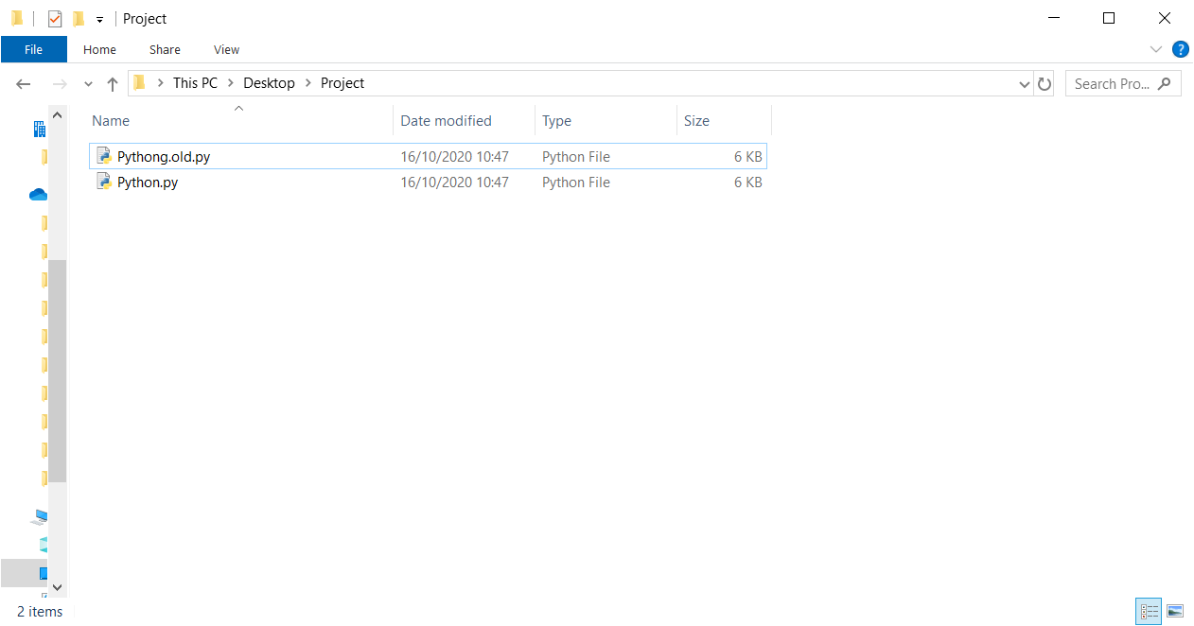

# Centralised Version Control:

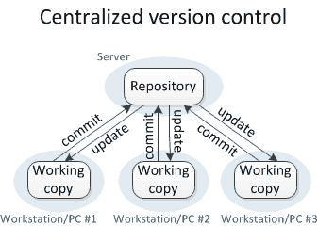

(Image 1: A representation of how centralised version control works

<https://homes.cs.washington.edu/~mernst/advice/version-control.html> - 17/10/2020)

Centralised version control system (CVCS) is based around the idea that there is a single central server/repository, in which users will “pull” down a version, make changes and then commit their changed version to the central repository for review.

# Distributed Version Control:

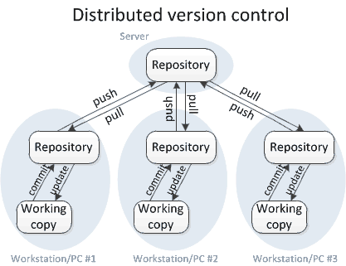

(Image 2: A representation of how decentralised version control works

<https://homes.cs.washington.edu/~mernst/advice/version-control.html> - 17/10/2020)

Distributed version control system (DVCS), also known as decentralised, the user will have their own repository, and local copy in which they work on and make changes. The user will then commit and push the changes to their own repository – it is then the main repository developer’s duty to then go to your repository and pull your changes and update the main repository.

# Differences between centralised and distributed:

As we’ve researched, there appears to be many differences with centralised vs decentralised with decentralised having the better outcome. A centralised system is a single point of failure and this can be achieved by the central repository having downtime, or an unsolicited change which was pushed and implanted.

However, a decentralised system is quick and efficient, due to working on a “local” file first, and developers can view the users’ changes on their own repository before they pull for implementation on the live production repository – which overall makes merging and creating branches effectively much easier.